1. Install Twilio package  
   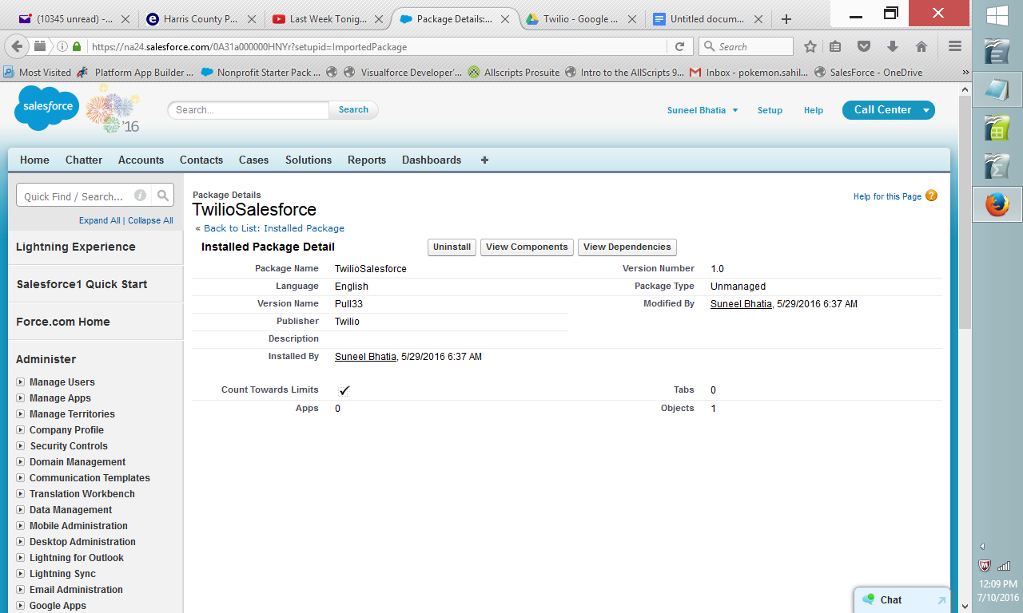
2. Setup the twillio settings to include the account ID (setup->develop->custom settings->click on manage next to the twillo->then click on the twillio link->then click on edit->get the settings from twillio website->enter them here and save. This is the account that this Salesforce org will use to send out phone and text messages.

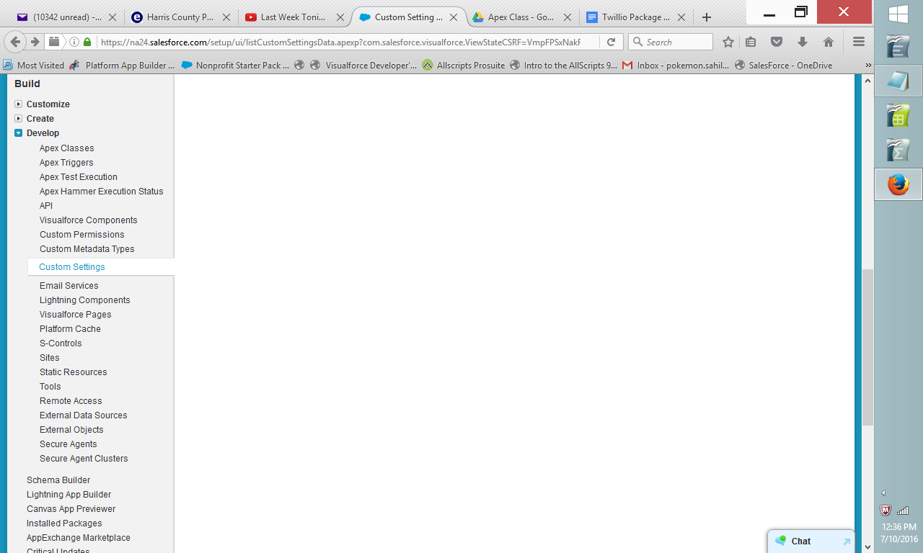  
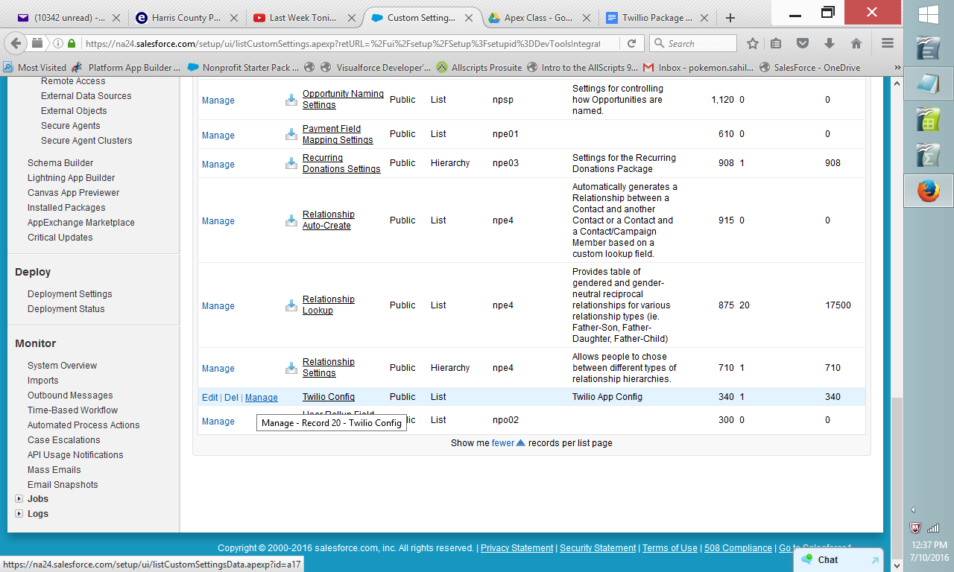  
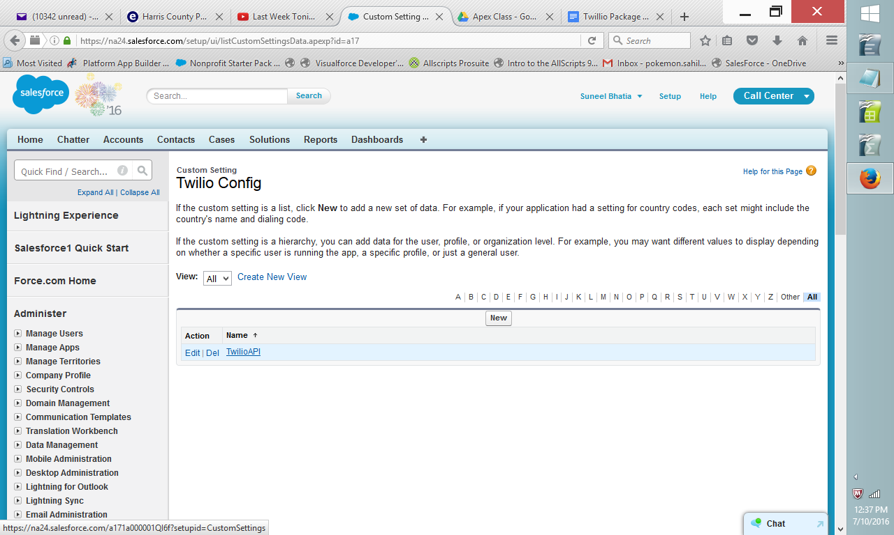  
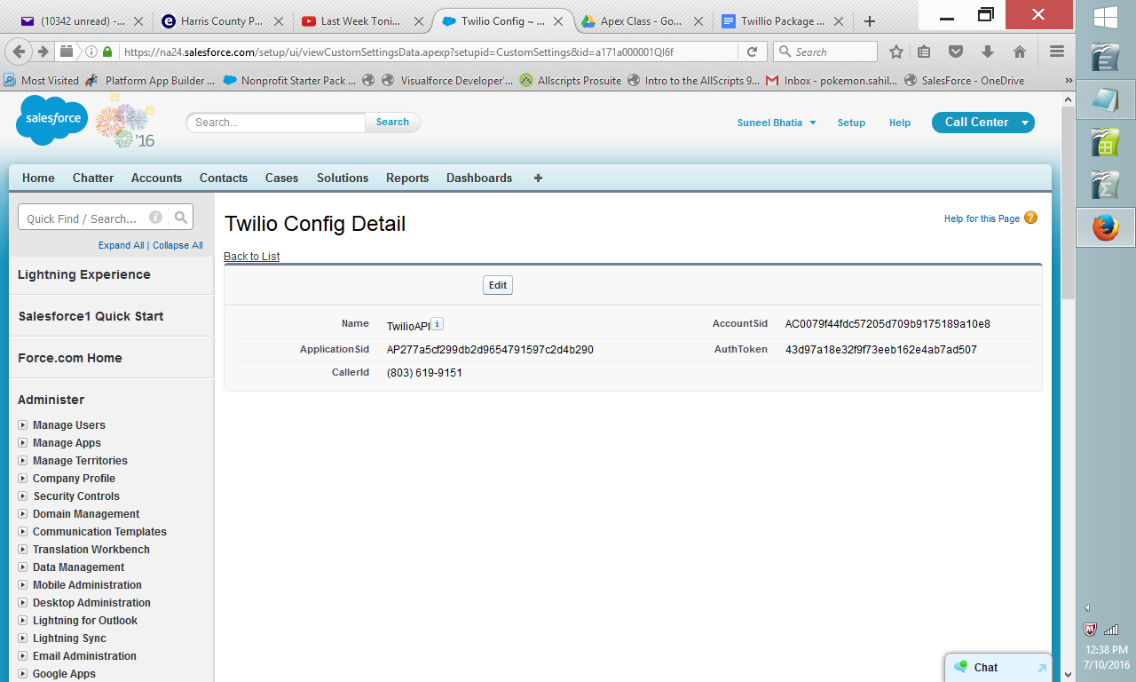  
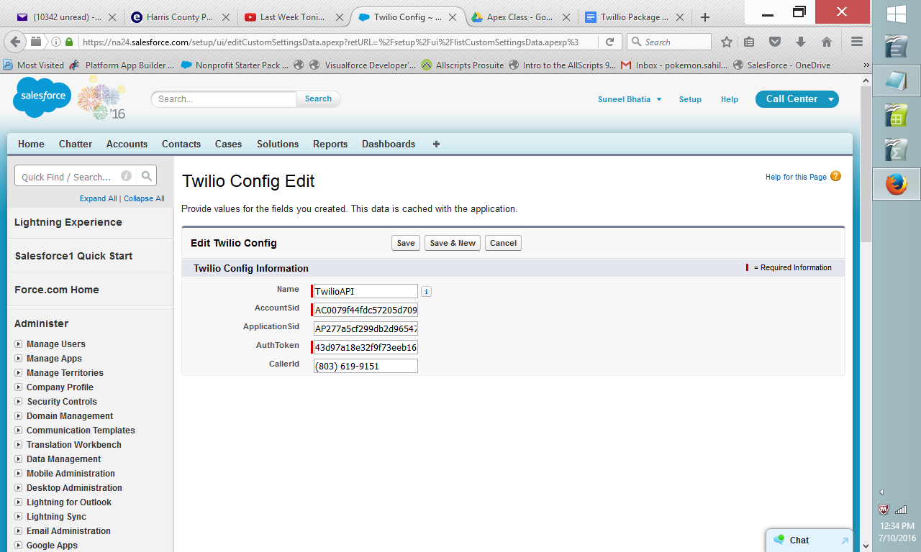

1. Install the following visualforce pages (setup->develop->visualforce pages)
2. Install the first page (copy and paste from the file in the folder). This is for making outbound phone calls.  
   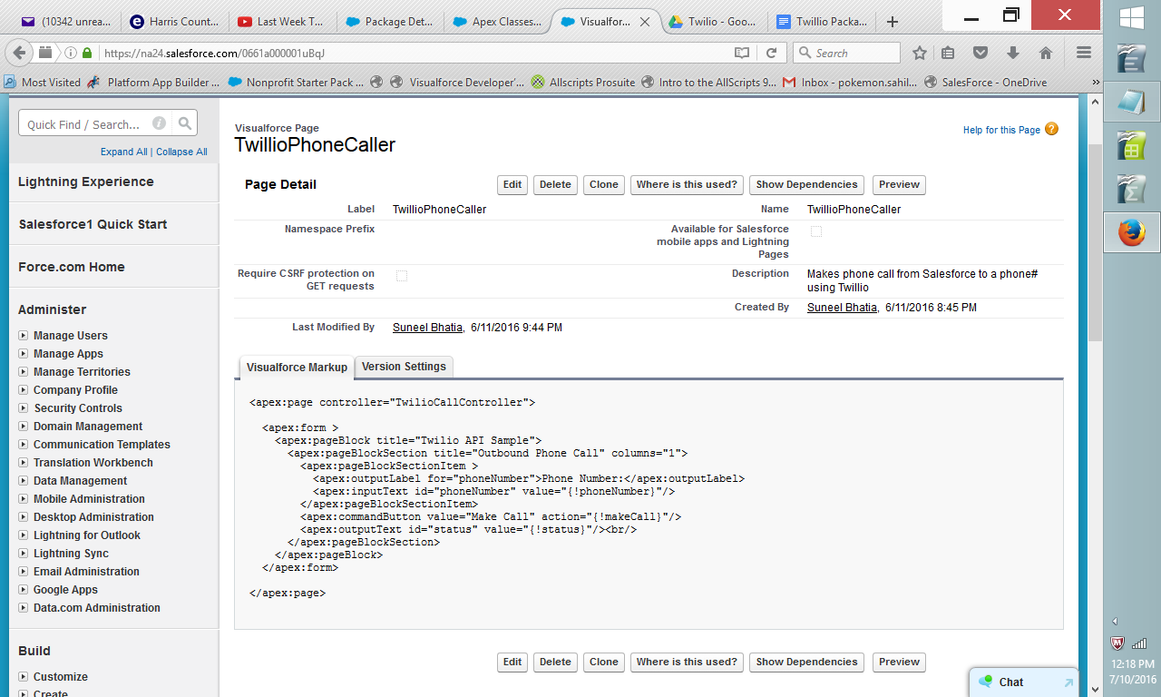
3. Install the second visual force page (copy and paste from the file in the folder). This is for sending outbound text messages.  
   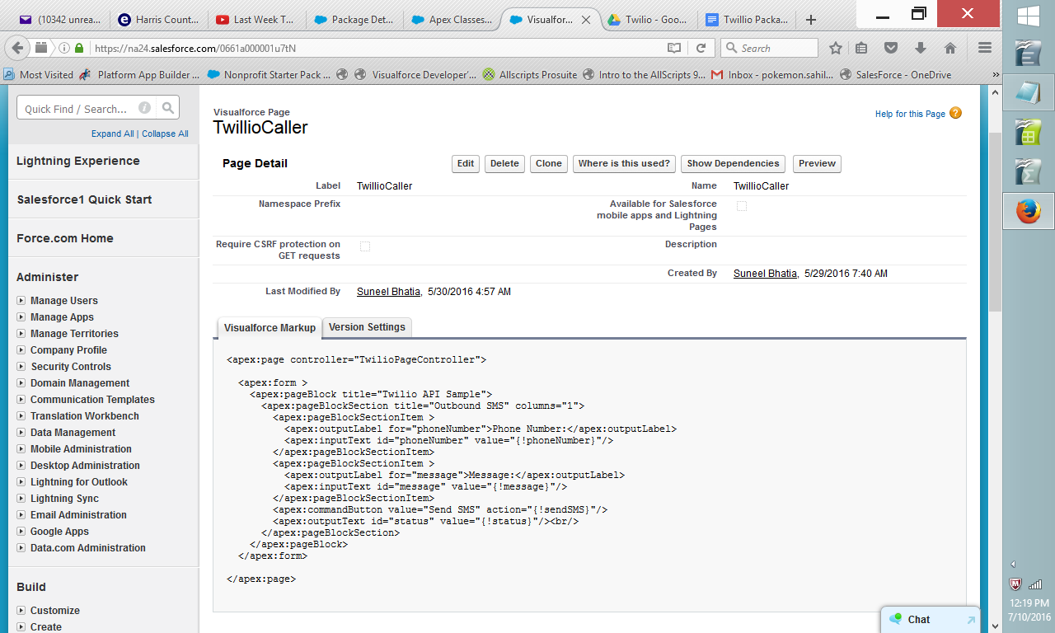
4. Install the apex classes (setup->develop->classes)
5. Install the first apex class (copy the code from the file in the folder)  
   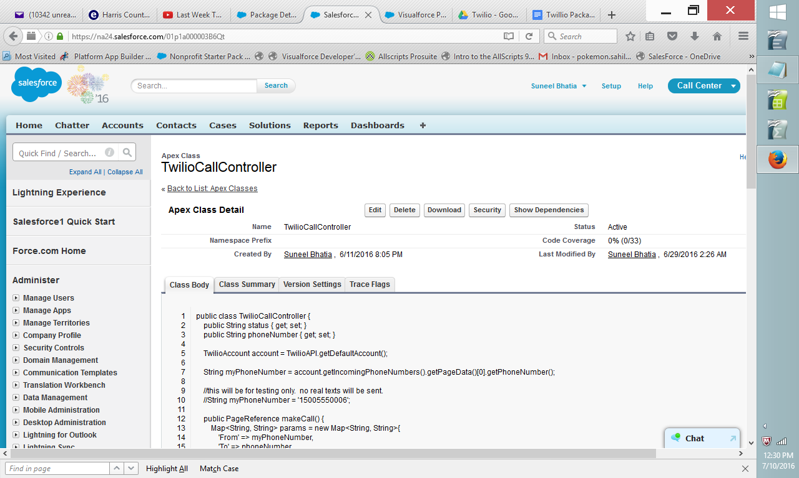
6. Copy the second apex class (copy the code from the file in the folder)  
   